

**STUDENT NAME: KUNDANANJI SIAME**

**STUDENT NUMBER: 20157314**

**PROGRAMME: COMPUTER ENGINEERING**

**TASK: ARCHITECTURAL DESIGN ASSINGMENT**

**DUE DATE: 22-SEPTEMBER-2021**

**LECTURER: DR SAMPA NKONDE**

**COURSE: SOFTWARE DEVELOPMENT**

1. **Introduction**
   1. **Purpose**

This document aims at giving a comprehensive overview of the architectural designs of the mobile advertising system. It is made to convey the different architectural decisions made on the system using the 4+1 view model and it will be focused on the **information** **system generic** architectural model because of its nature.

* 1. **Scope**

The document provides an architectural overview of the mobile advertisement system. The mobile advertisement system is being developed to support people that do business transactions online.

The models in the system were constructed in Visual paradigm.

* 1. **References**
     1. Ian Sommerville software engineering 10th edition.
     2. The Rational unified process made easy: A practitioner’s guide to the RUP.
     3. 4+1 view models by Phillipe Kruchten.

1. **Architectural representations and documentation**

This document presents the architecture as a series of views; Logical view, Process view, Physical view, Development view plus use case view. These are views on an underlying unified modelling language developed in Visual paradigm.

1. **Architectural design evaluation**

The system will be evaluated using Architecture Trade off analysis. This will be done by first preparing a short questionnaire on quality attributes considered in the architecture design before the actual evaluation session commences. This whole process will involve the stockholders and the evaluation team which includes the developers.

**Logical view**

A description of the logical view of the architecture. Describes the most important classes, their organization in service packages and subsystems, and the organization of these subsystems into layers. Also describes the most important use-case realizations, for example, the dynamic aspects of the architecture. Class diagrams may be included to illustrate the relationships between architecturally significant classes, subsystems, packages and layers. The system will be structured using a functional oriented approach, where the system is Brocken down into a set of interacting programs. The system will be decomposed by looking at each object from the logical perspective.

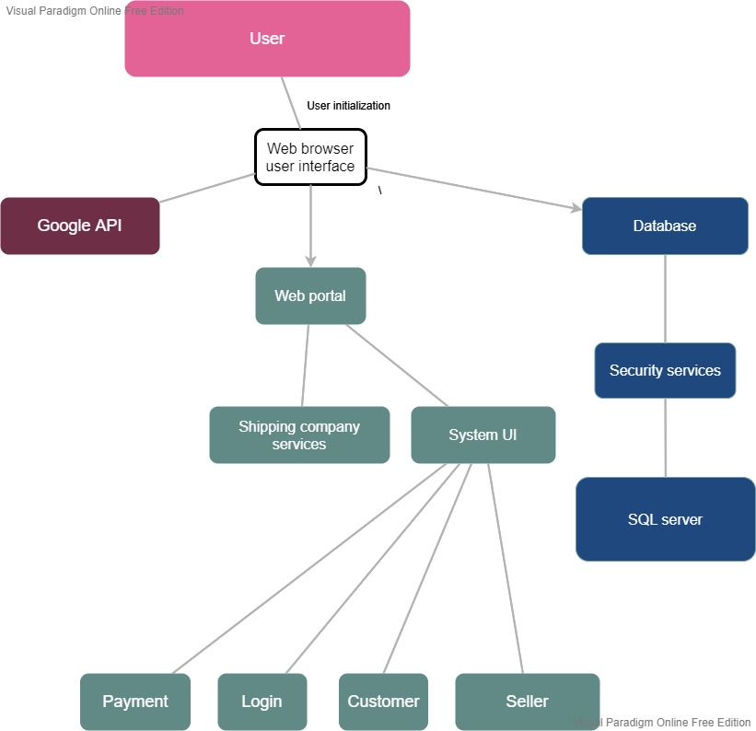

**Process view**

A process is a grouping of tasks that form an executable unit. The process architecture takes into account some none functional requirements such as performance and availability. The software is divided into a set of independent tasks. A task is a separate thread of control that can be scheduled individually on one processing node. Tasks are identified as major tasks or minor tasks. A major task is one that can exist independently while a minor task is one that is added locally to the system for implementation purposes.

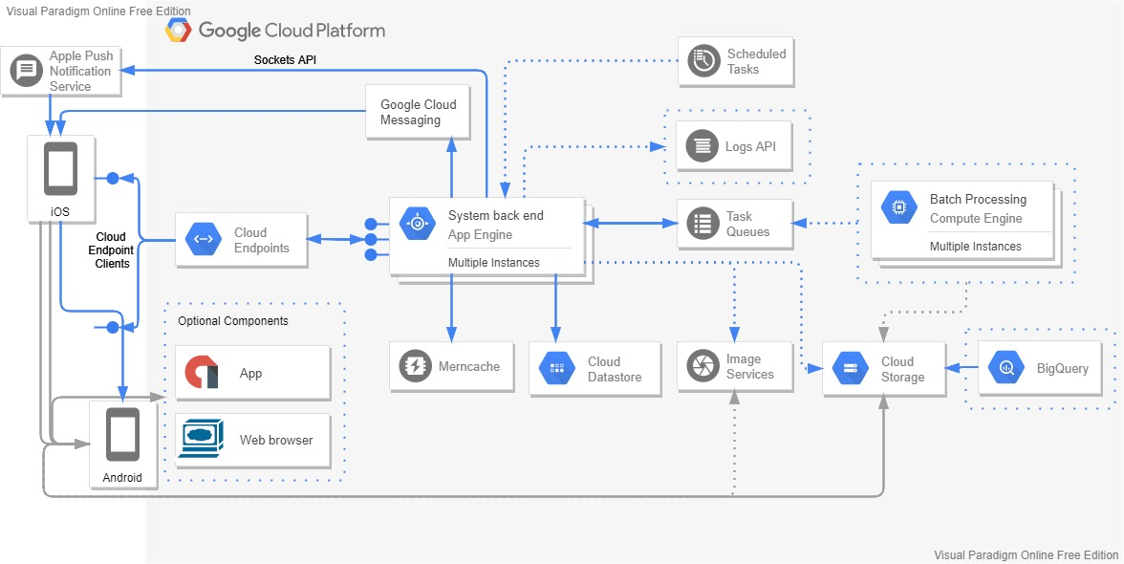

**Development view**

The development architecture takes into account the organization of separate modules that make up a system. Every software subsystem that are developed separately by different software developers. The subsystems are arranged in a hierarchy of layers, each layer providing a narrow and well-defined interface to the layer above it. Because of this reason and the fact that the system of focus is an information system, it is best to use the layered architecture to show the organization of the sub systems and how they inter operate.

0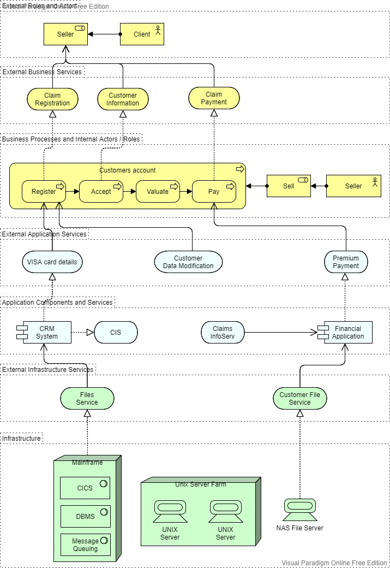

**Physical view**

The physical architecture of a system takes into account primarily the non-functional requirements of system such as reliability, performance and scalability. The system executes on a network of computer or processing nodes. The elements identified at this stage have to be associated with various nodes, all this means the system will be distributed using a client server architecture.

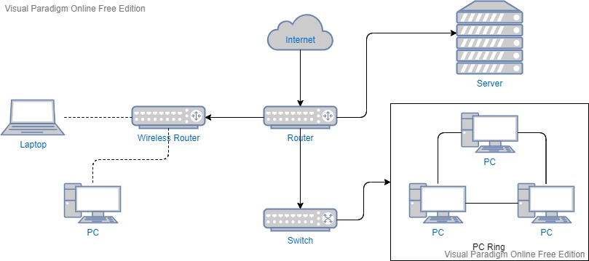

**+1 Use case**

